UI Prototype Documentation
Project: Melon - AI-Powered Learning Platform
Purpose. This document presents the Melon UI prototype in a formal report format and verifies that the prototype screens correspond to the use-case specifications. Each screen includes its purpose, visible interface elements, user interaction method, and explicit use-case alignment.
1. Prototype Overview
Melon is an AI-powered learning platform for children, with separate interaction flows for parents, children, and administrators. The prototype follows a child-friendly neobrutalist visual style, using bold borders, high-contrast cards, gamification components, and clear action buttons. The screen set covers public onboarding, parent account management, child learning, AI-assisted practice generation, progress tracking, profile customization, and administrative content review.

2. Use-Case Alignment Basis
The UI screens were checked against the provided use-case specification table. The specification defines account access use cases (UC-01.x), child sub-profile management (UC-02.x), lesson and progress use cases (UC-03.x), AI/RAG generation use cases (UC-04.x), safety moderation (UC-05.1), gamification use cases (UC-06.x), and parent dashboard/reporting use cases (UC-07.x).

3. Screen Coverage Matrix
Screen ID | Screen Name | Primary Actor | Related Use Case(s) | Requirement Role
S01 | Landing Page / Main Screen | Visitor / Parent | UC-01.1 Register Parent Account; UC-01.2 Login System | Key scenario
S02 | Parent Dashboard | Parent / Guardian | UC-07.1 View Overview Dashboard; UC-07.2 Configure Screen Time; UC-07.3 Configure Learning Path Emphasis; UC-07.4 Weekly Email Report | Key scenario
S03 | Family Management | Parent / Guardian | UC-02.1 Create Sub-profile for Child; UC-02.2 Update / Delete Sub-profile | Key scenario
S04 | Child Progress | Child | UC-03.3 Save Learning Progress; UC-06.1 Accumulate Melon Points & XP; UC-06.2 Calculate Streak; UC-06.3 Receive Badges | Key scenario
S05 | Practice Submission and AI Extraction | Child / Parent-supervised User | UC-04.1 Upload PDF Document (RAG Pipeline); UC-04.2 Generate AI Quiz; UC-04.5 AI Hint Support | Key scenario
S06 | Lesson Catalog | Child | UC-03.1 View Learning Roadmap; UC-03.2 Study Static Video / Flashcard Lesson | Key scenario
S07 | Lesson Interaction | Child | UC-03.2 Study Static Video / Flashcard Lesson; UC-03.3 Save Learning Progress; UC-03.4 Read Question Aloud (TTS Service); UC-04.5 AI Hint Support | Key scenario
S08 | Child Profile Customization | Child / Parent | UC-02.2 Update / Delete Sub-profile; UC-06.5 Redeem Virtual Rewards | Key scenario
S09 | Admin Question Bank Review | Admin | Supporting UC-04.2 Generate AI Quiz; Supporting UC-05.1 Content Safety Moderation | Supplementary support screen

Verification result. The document contains one main screen and eight scenario screens. Eight screens are directly mapped to use-case scenarios and can be counted as key scenario screens, which exceeds the minimum requirement of at least five key scenario screens. The admin question-bank screen is retained as a supplementary support screen because the provided use-case specification does not define a standalone Admin question-bank use case.

4. Use-Case Traceability Summary
Use-Case Area | Relevant UC IDs | Covered By Screen(s) | Coverage Note
Authentication and onboarding | UC-01.1, UC-01.2 | S01 | Entry point is shown; detailed login/register modal is not separately sketched.
Child profile management | UC-02.1, UC-02.2 | S03, S08 | Create, view, and update profile information are represented.
Lesson roadmap and learning | UC-03.1, UC-03.2, UC-03.3, UC-03.4 | S06, S07, S04 | Lesson browsing, lesson interaction, and progress persistence are represented; TTS is described as an action within the lesson workflow.
AI/RAG practice generation | UC-04.1, UC-04.2, UC-04.5 | S05, S07 | Upload/paste, extraction, quiz generation, and AI assistance are represented.
Safety moderation | UC-05.1 | S09 | Safety moderation is represented indirectly through admin review and content QA.
Gamification | UC-06.1, UC-06.2, UC-06.3, UC-06.5 | S04, S08 | XP, badges, and profile/avatar personalization are represented.
Parent analytics and controls | UC-07.1, UC-07.2, UC-07.3, UC-07.4 | S02 | Dashboard analytics are represented; screen-time and email reporting controls are described as parent-dashboard actions.

5. Screen Descriptions

5.1 S01 - Landing Page / Main Screen
Related use case(s): UC-01.1 Register Parent Account; UC-01.2 Login System
Scenario: Account access and onboarding entry point
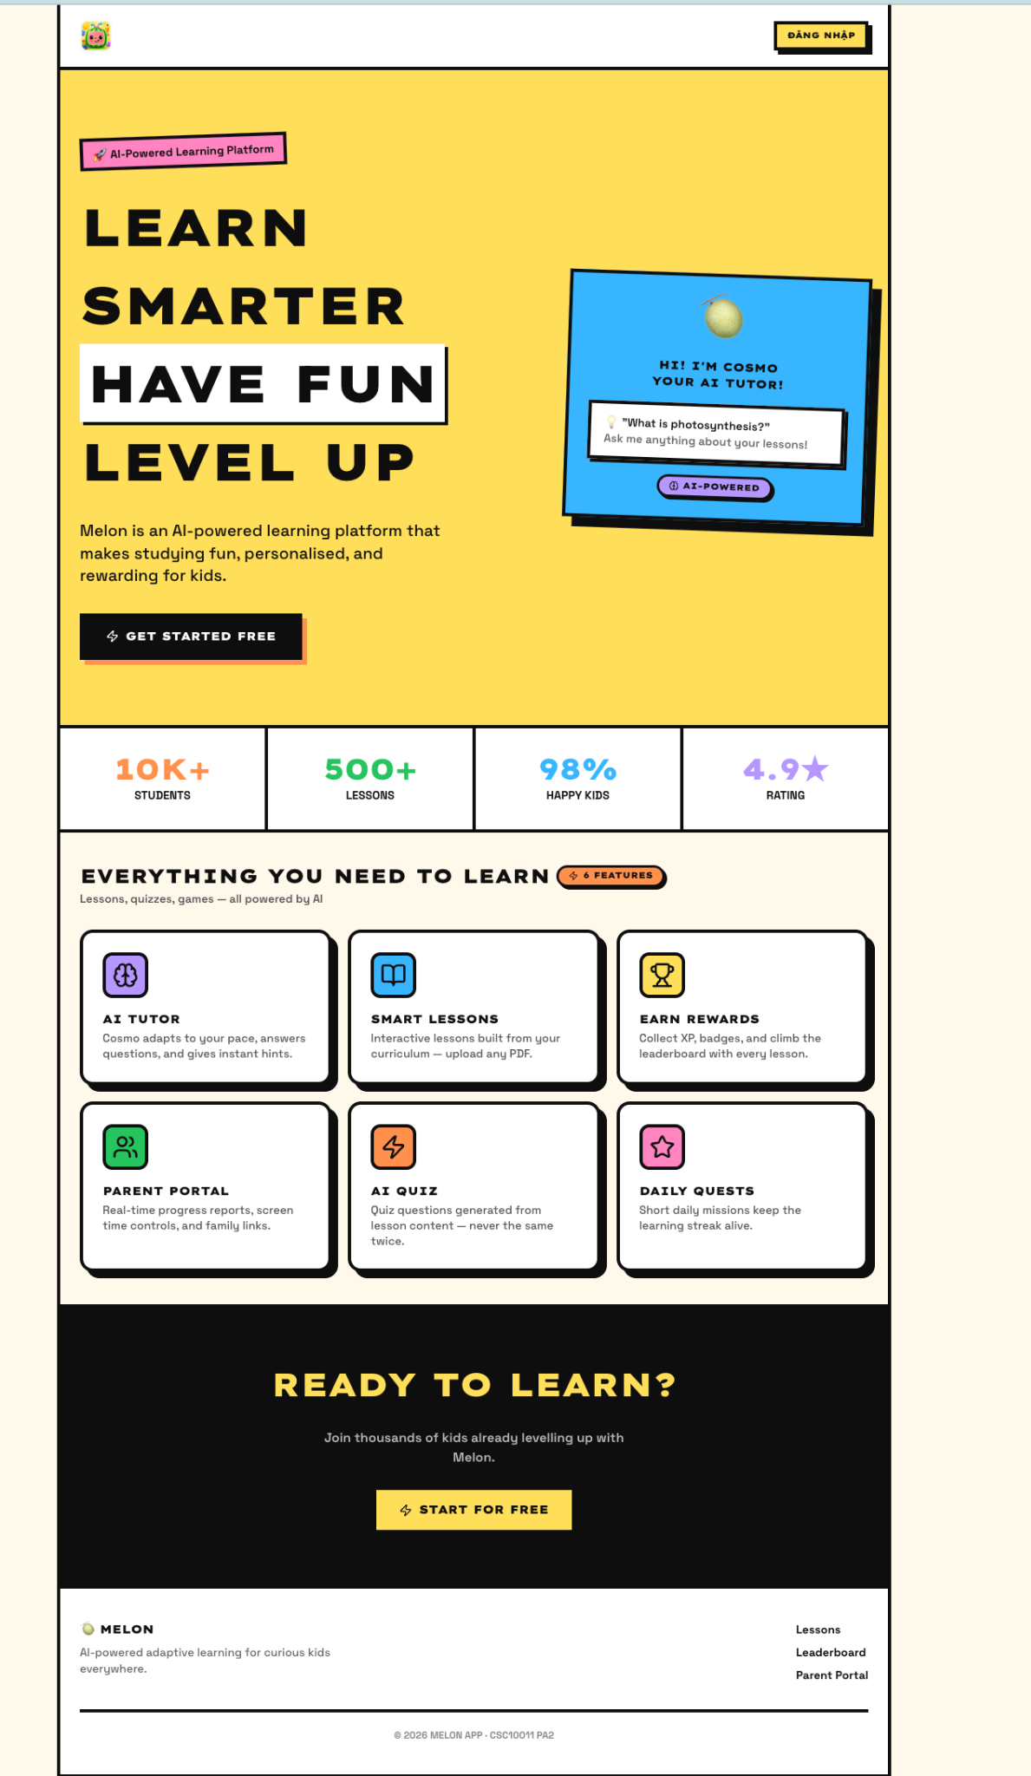
Figure 1. Landing Page / Main Screen screen.
Purpose | Serves as the public entry point to the Melon platform. It introduces the product value proposition and guides new or returning users toward registration, login, or role-specific onboarding.
What the screen shows | The Melon logo, an AI-powered learning platform label, hero message, call-to-action button, AI tutor preview, and summary credibility metrics such as number of students, lessons, and satisfaction rate.
How users use it | A visitor reviews the platform information and selects the primary call-to-action to begin the parent registration or login flow. This screen supports the beginning of the authentication use cases before the user reaches role-specific screens.
Use-case alignment | Aligned. The screen is the main entry point for the account creation and login scenarios described in UC-01.1 and UC-01.2.

5.2 S02 - Parent Dashboard
Related use case(s): UC-07.1 View Overview Dashboard; UC-07.2 Configure Screen Time; UC-07.3 Configure Learning Path Emphasis; UC-07.4 Weekly Email Report
Scenario: Parent monitors child performance and learning status
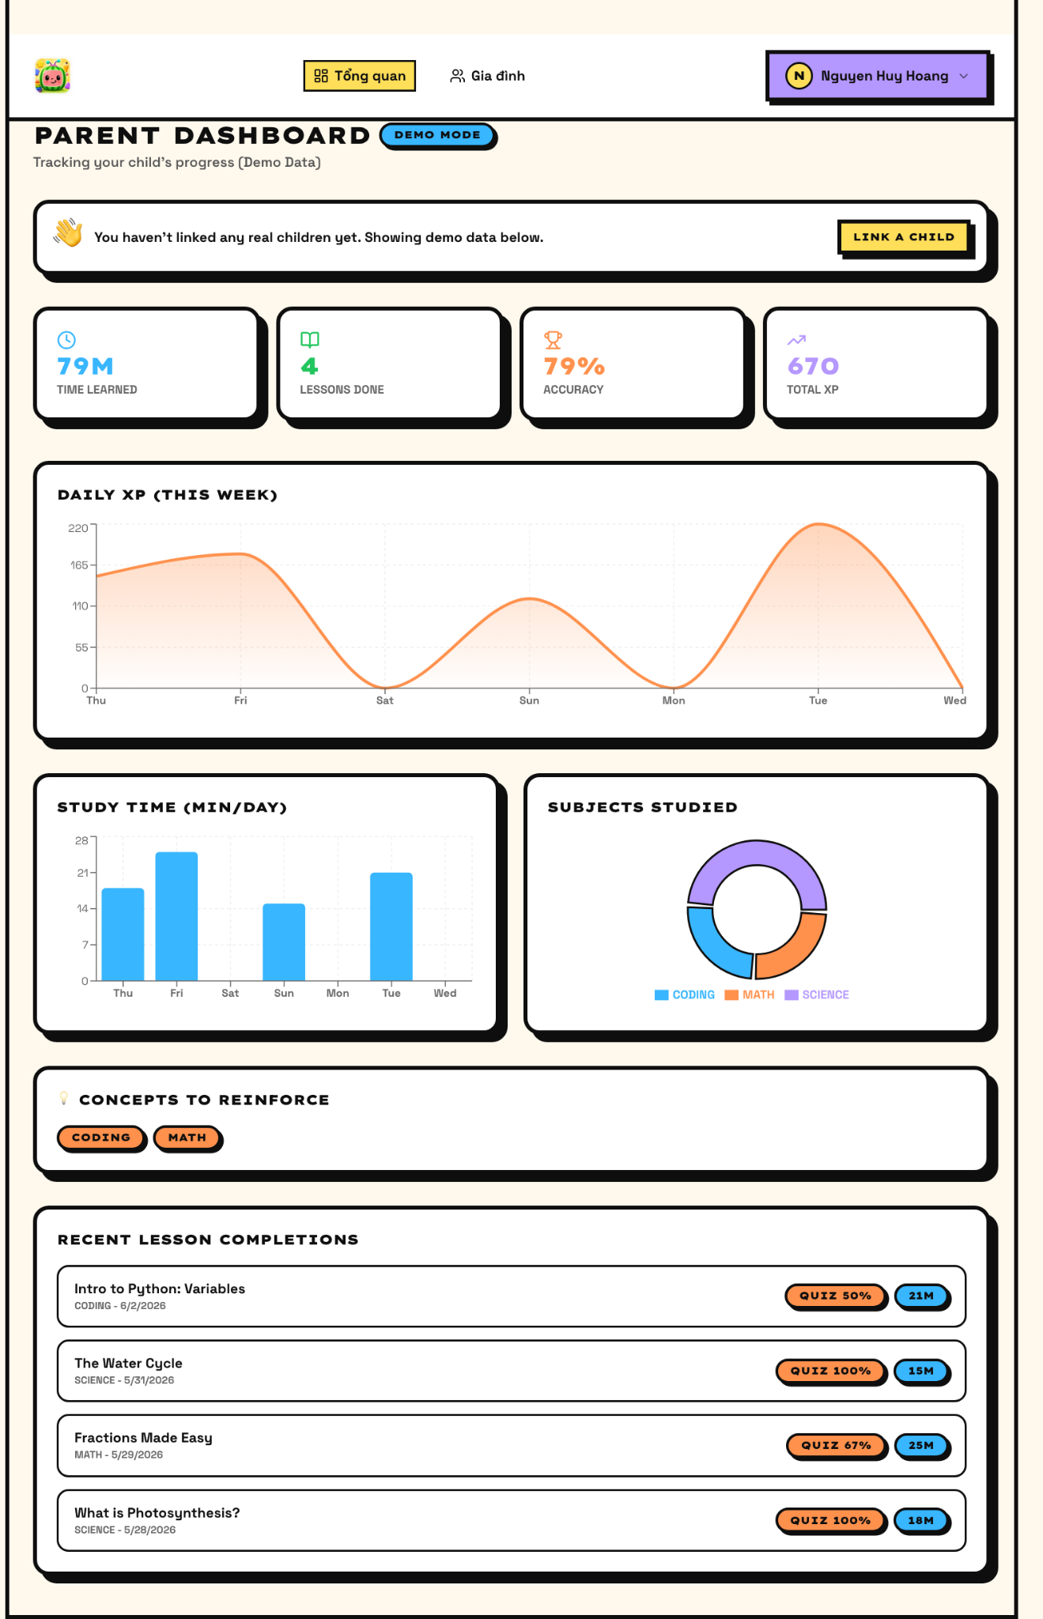
Figure 2. Parent Dashboard screen.
Purpose | Provides the parent with a consolidated overview of the child’s learning activity, progress trends, and performance indicators.
What the screen shows | Overview and family navigation, a demo-mode notice, cards for learning time, completed lessons, accuracy, total XP, daily XP chart, study-time chart, subject distribution, and improvement targets.
How users use it | The parent opens the dashboard to inspect the child’s progress, identify weak subjects, evaluate study consistency, and determine whether screen-time limits or learning-path emphasis should be adjusted.
Use-case alignment | Aligned. The screen directly implements the parent overview dashboard in UC-07.1 and provides visual grounding for the control/reporting use cases in UC-07.2 to UC-07.4.

5.3 S03 - Family Management
Related use case(s): UC-02.1 Create Sub-profile for Child; UC-02.2 Update / Delete Sub-profile
Scenario: Parent creates and manages child learning profiles
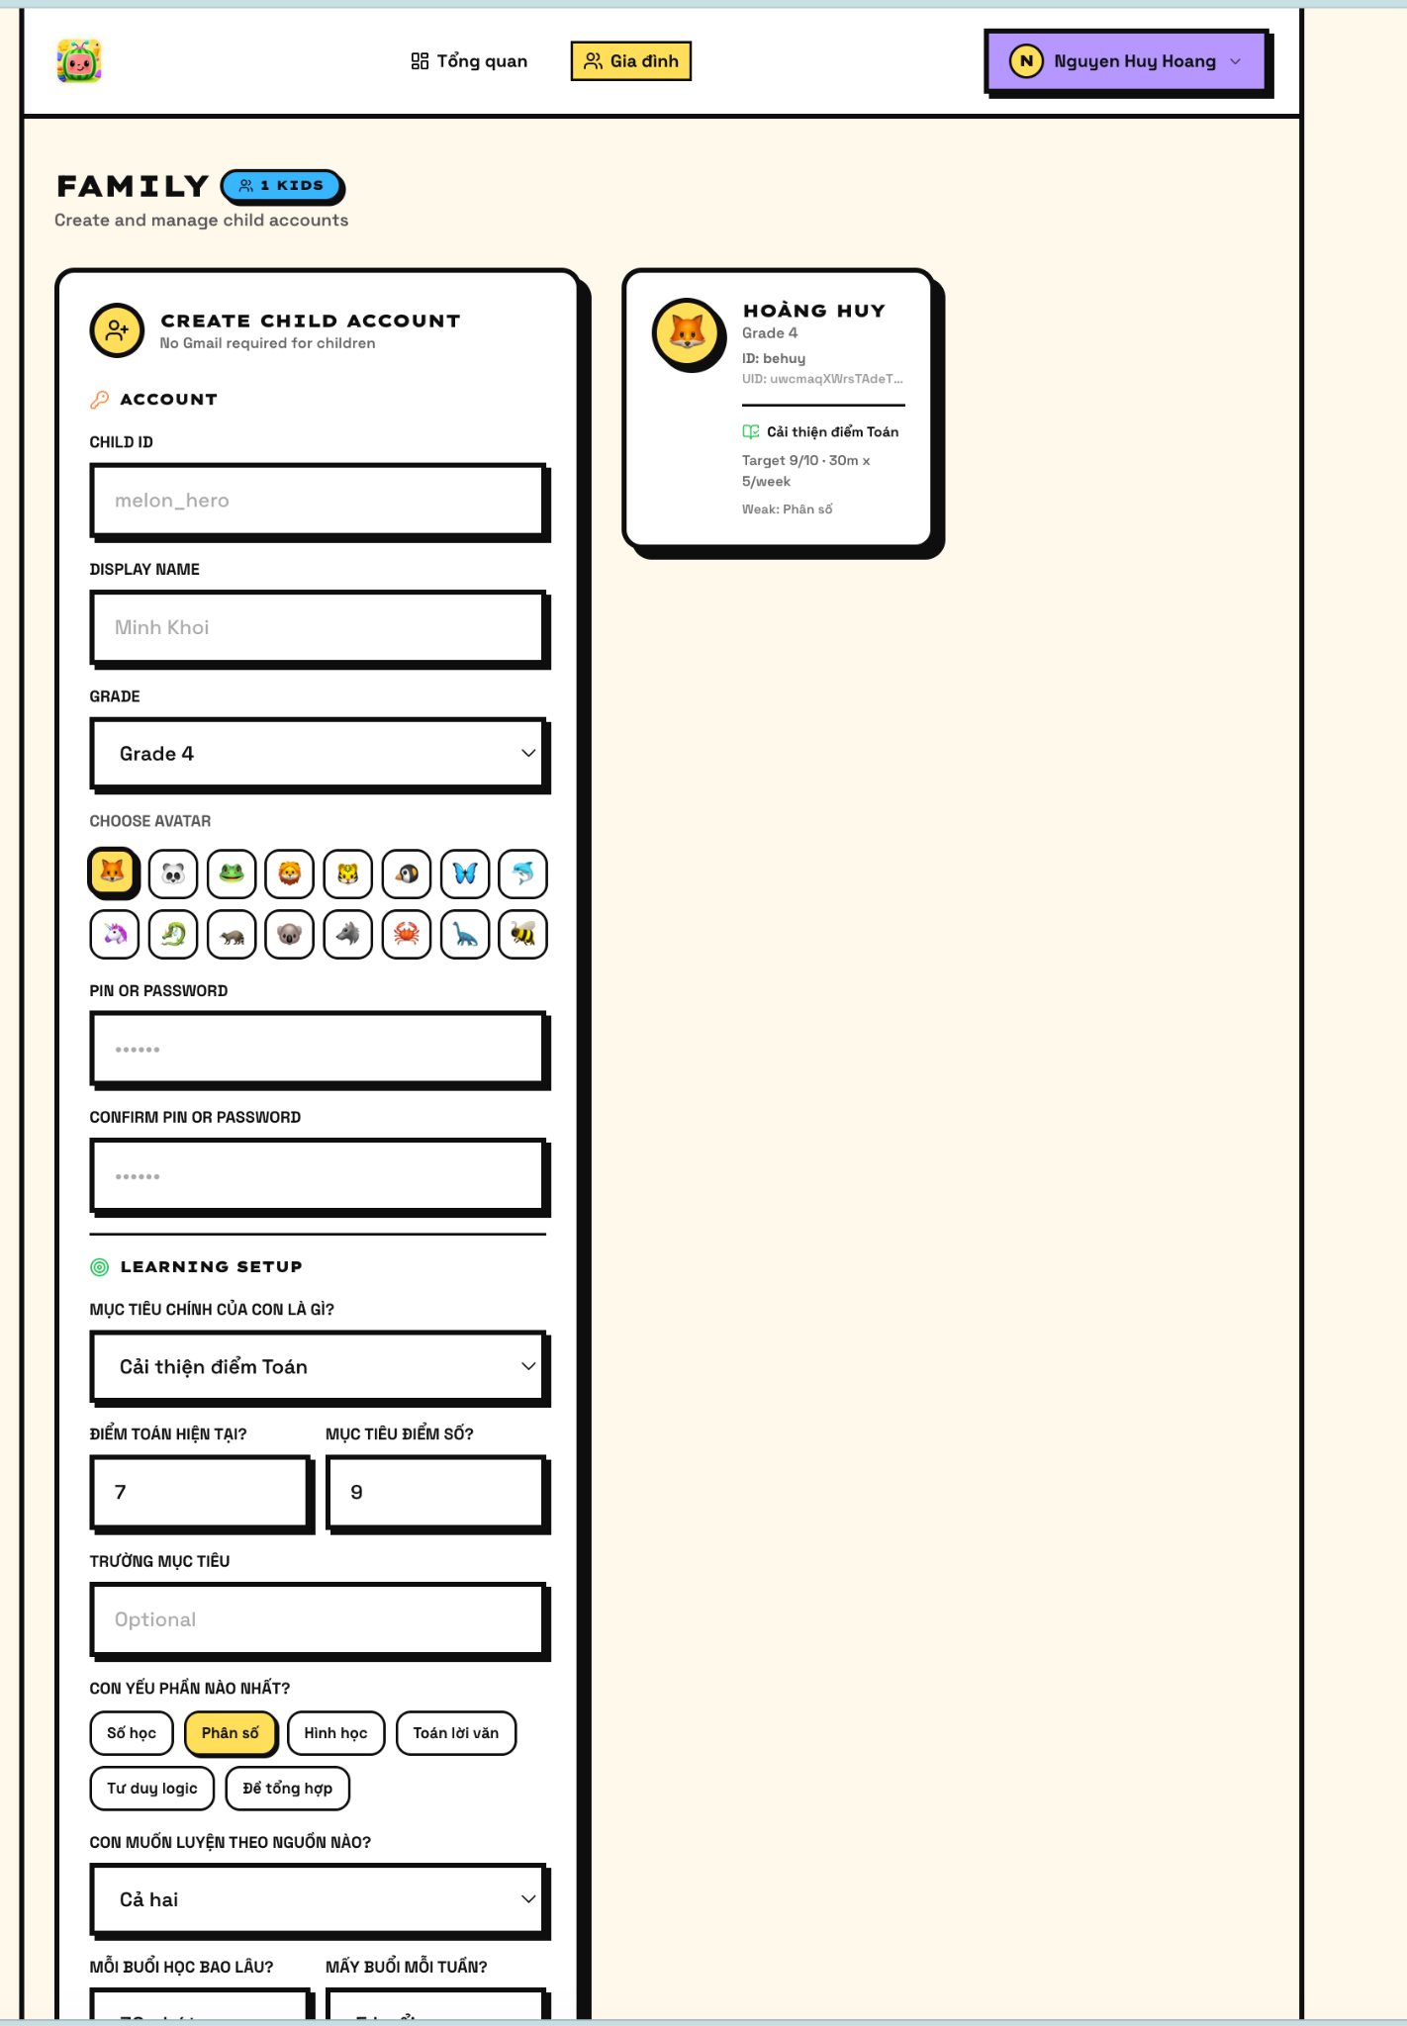
Figure 3. Family Management screen.
Purpose | Allows a parent to create, configure, and review child sub-profiles used for personalized learning.
What the screen shows | Child account creation form, child ID field, display name field, grade selector, avatar selection grid, PIN/password fields, confirmation fields, save action, and an existing child profile card.
How users use it | The parent enters the child’s profile information, selects grade and avatar, sets a PIN or password, and saves the profile. Existing profile cards allow the parent to review or later update child metadata.
Use-case alignment | Aligned. The displayed inputs correspond to the profile metadata, PIN, and database initialization flow defined in UC-02.1, and the profile card supports UC-02.2.

5.4 S04 - Child Progress
Related use case(s): UC-03.3 Save Learning Progress; UC-06.1 Accumulate Melon Points & XP; UC-06.2 Calculate Streak; UC-06.3 Receive Badges
Scenario: Child reviews progress, XP, badges, and recent activity
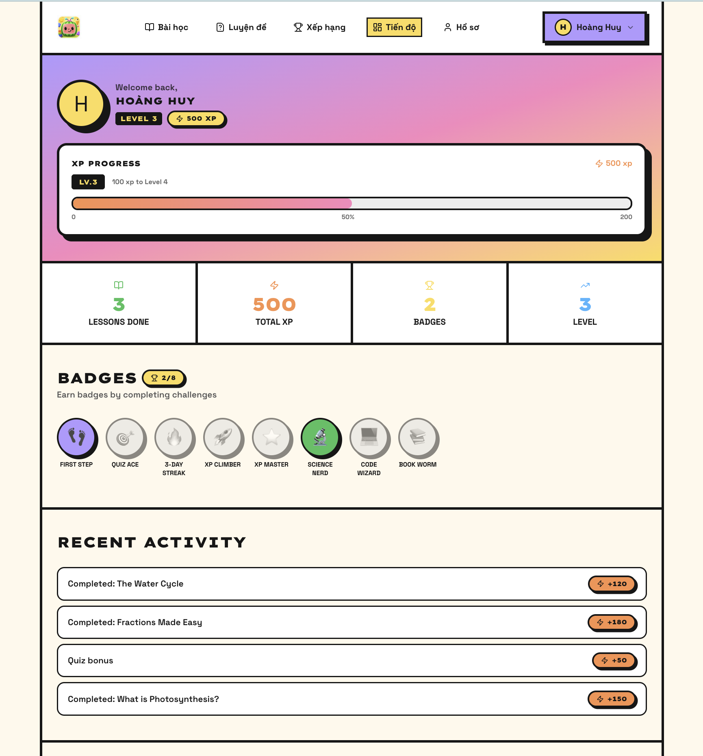
Figure 4. Child Progress screen.
Purpose | Motivates the child by visualizing gamified learning progress, achievements, and recent learning activity.
What the screen shows | Child identity, level, XP progress bar, lessons completed, total XP, badge count, earned and locked badge states, and a recent activity list.
How users use it | The child checks current level progress, reviews unlocked badges, and uses the recent activity list to understand what has been completed and what should be attempted next.
Use-case alignment | Aligned. The progress metrics match the XP, points, streak, badge, and progress persistence use cases in UC-03.3 and UC-06.1 to UC-06.3.

5.5 S05 - Practice Submission and AI Extraction
Related use case(s): UC-04.1 Upload PDF Document (RAG Pipeline); UC-04.2 Generate AI Quiz; UC-04.5 AI Hint Support
Scenario: User submits a worksheet or exam source for AI-assisted question extraction
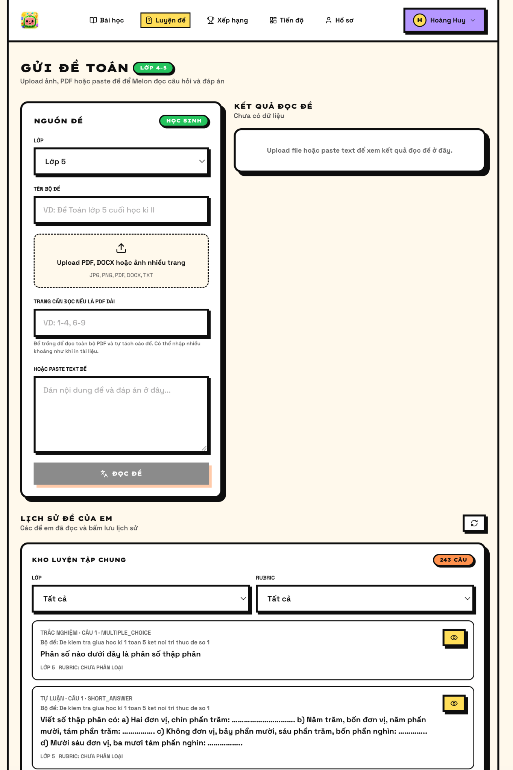
Figure 5. Practice Submission and AI Extraction screen.
Purpose | Supports the RAG-based practice workflow in which uploaded or pasted learning material is processed into structured exercises.
What the screen shows | Grade selector, test title input, file upload area for PDF/DOCX/image files, page-range field, pasted-text field, extracted-result panel, generated questions, multiple-choice answers, and answer/explanation cards.
How users use it | The user selects the grade, uploads or pastes the practice source, optionally defines page ranges, and waits for Melon to parse the material. The extracted output can then be reviewed and used for practice.
Use-case alignment | Aligned with a minor actor clarification. UC-04.1 defines Parent as the primary upload actor, while the prototype presents a child-facing practice screen. The document therefore treats this as a parent-supervised child practice workflow.

5.6 S06 - Lesson Catalog
Related use case(s): UC-03.1 View Learning Roadmap; UC-03.2 Study Static Video / Flashcard Lesson
Scenario: Child browses available lessons and starts a selected learning activity
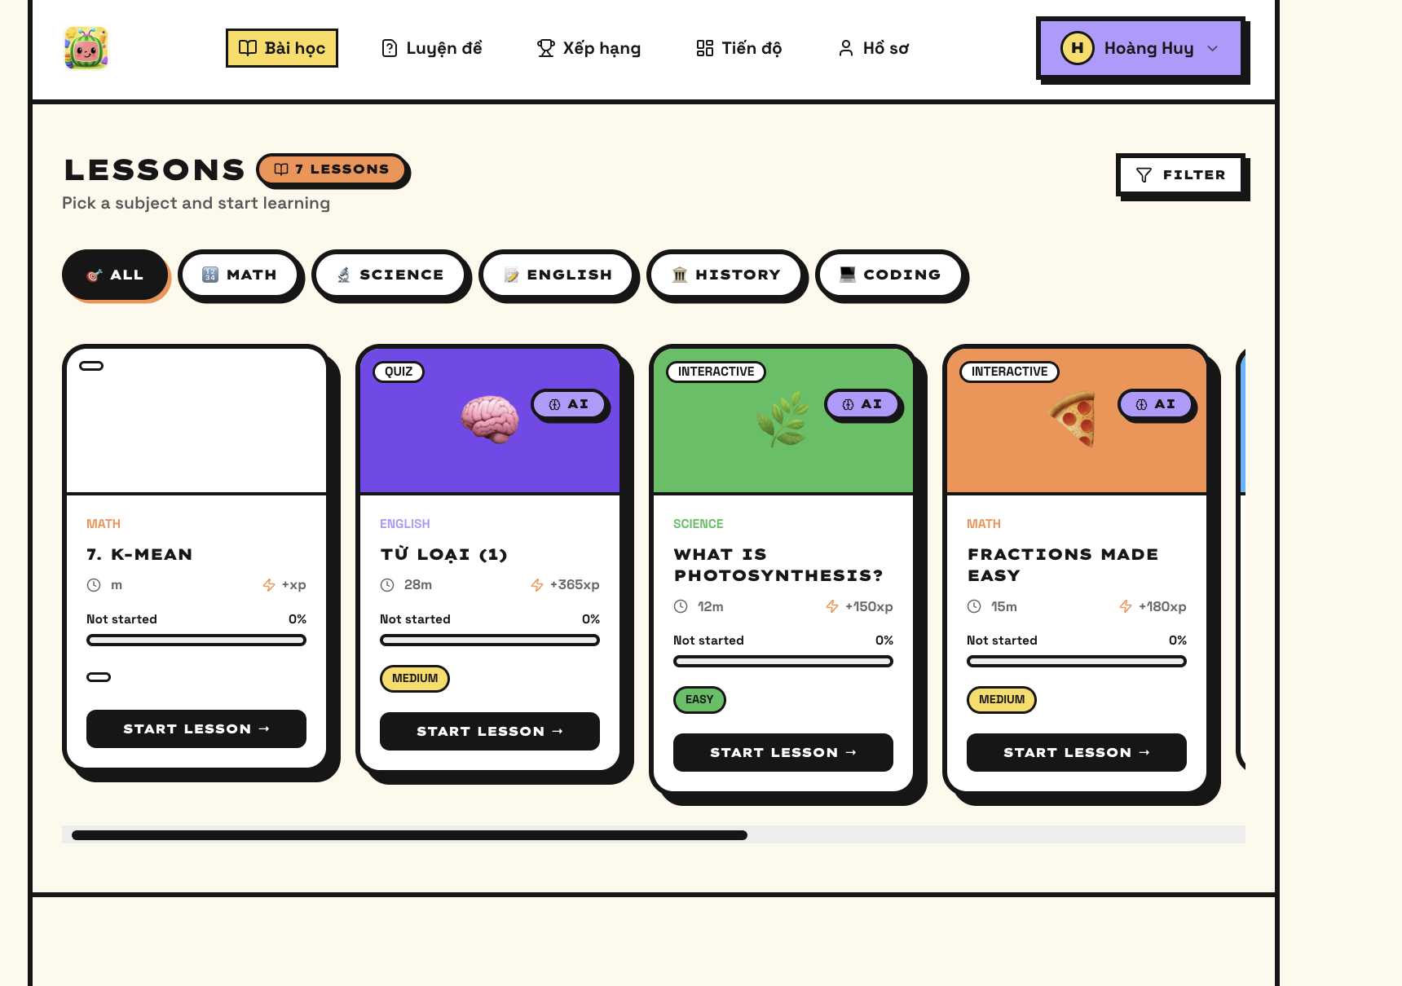
Figure 6. Lesson Catalog screen.
Purpose | Acts as the child’s main learning workspace for discovering lessons by subject and selecting the next activity.
What the screen shows | Subject filters, lesson cards, lesson type labels, estimated duration, XP reward, difficulty level, completion progress, and Start Lesson buttons.
How users use it | The child filters lessons by subject, compares lesson cards, and starts an appropriate learning activity. Progress bars help distinguish new lessons from partially completed lessons.
Use-case alignment | Aligned. The catalog operationalizes the roadmap and lesson-selection flow in UC-03.1 and UC-03.2.

5.7 S07 - Lesson Interaction
Related use case(s): UC-03.2 Study Static Video / Flashcard Lesson; UC-03.3 Save Learning Progress; UC-03.4 Read Question Aloud (TTS Service); UC-04.5 AI Hint Support
Scenario: Child completes a selected lesson and receives AI-assisted support
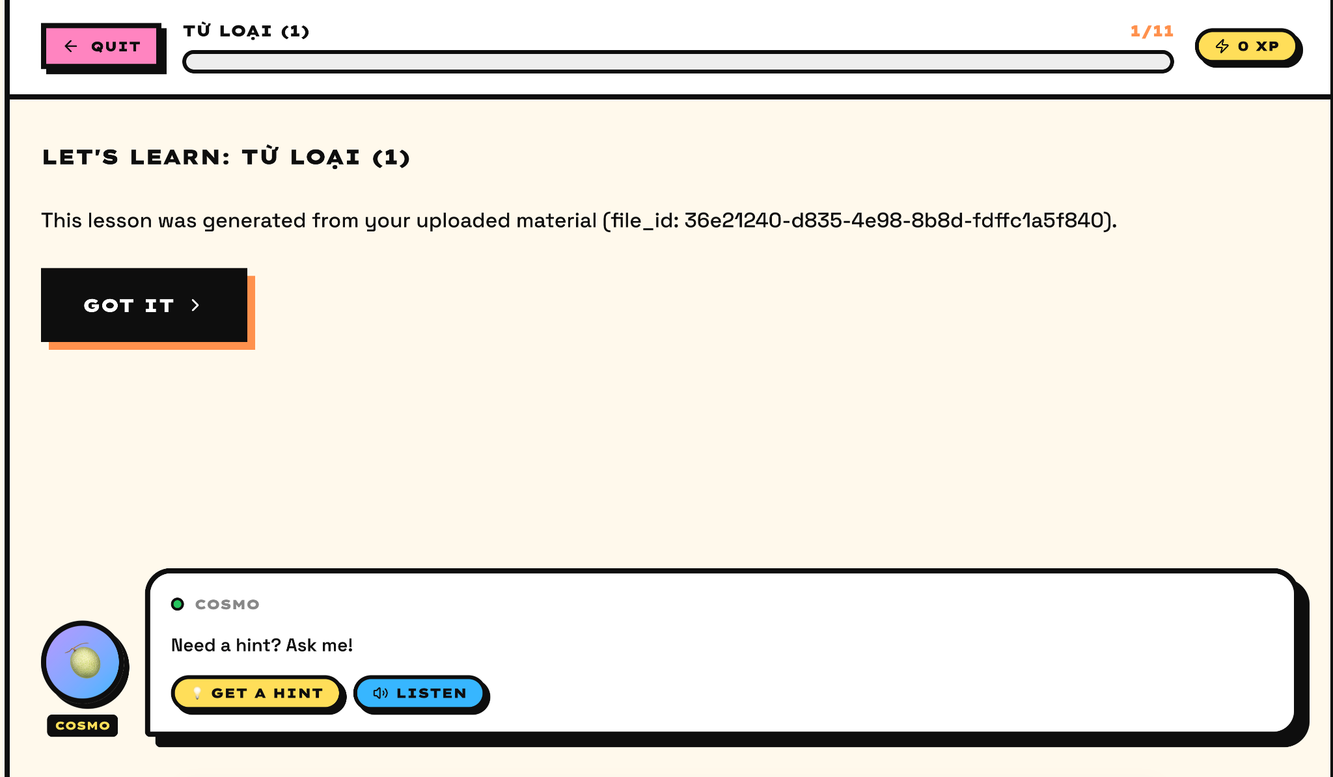
Figure 7. Lesson Interaction screen.
Purpose | Provides the in-lesson experience after the child selects a lesson from the catalog.
What the screen shows | Quit button, lesson title, progress bar, lesson content generated from uploaded material, confirmation action, and an AI assistant area that can provide hints or related assistance.
How users use it | The child reads or listens to the lesson content, confirms understanding with the action button, and can use the AI assistant area for additional help. Progress is saved as the child advances through the lesson.
Use-case alignment | Aligned. The screen corresponds to lesson consumption and progress persistence in UC-03.2 and UC-03.3. It also provides the UI location where TTS and hint support from UC-03.4 and UC-04.5 can be invoked.

5.8 S08 - Child Profile Customization
Related use case(s): UC-02.2 Update / Delete Sub-profile; UC-06.5 Redeem Virtual Rewards
Scenario: Child or parent customizes visible profile information
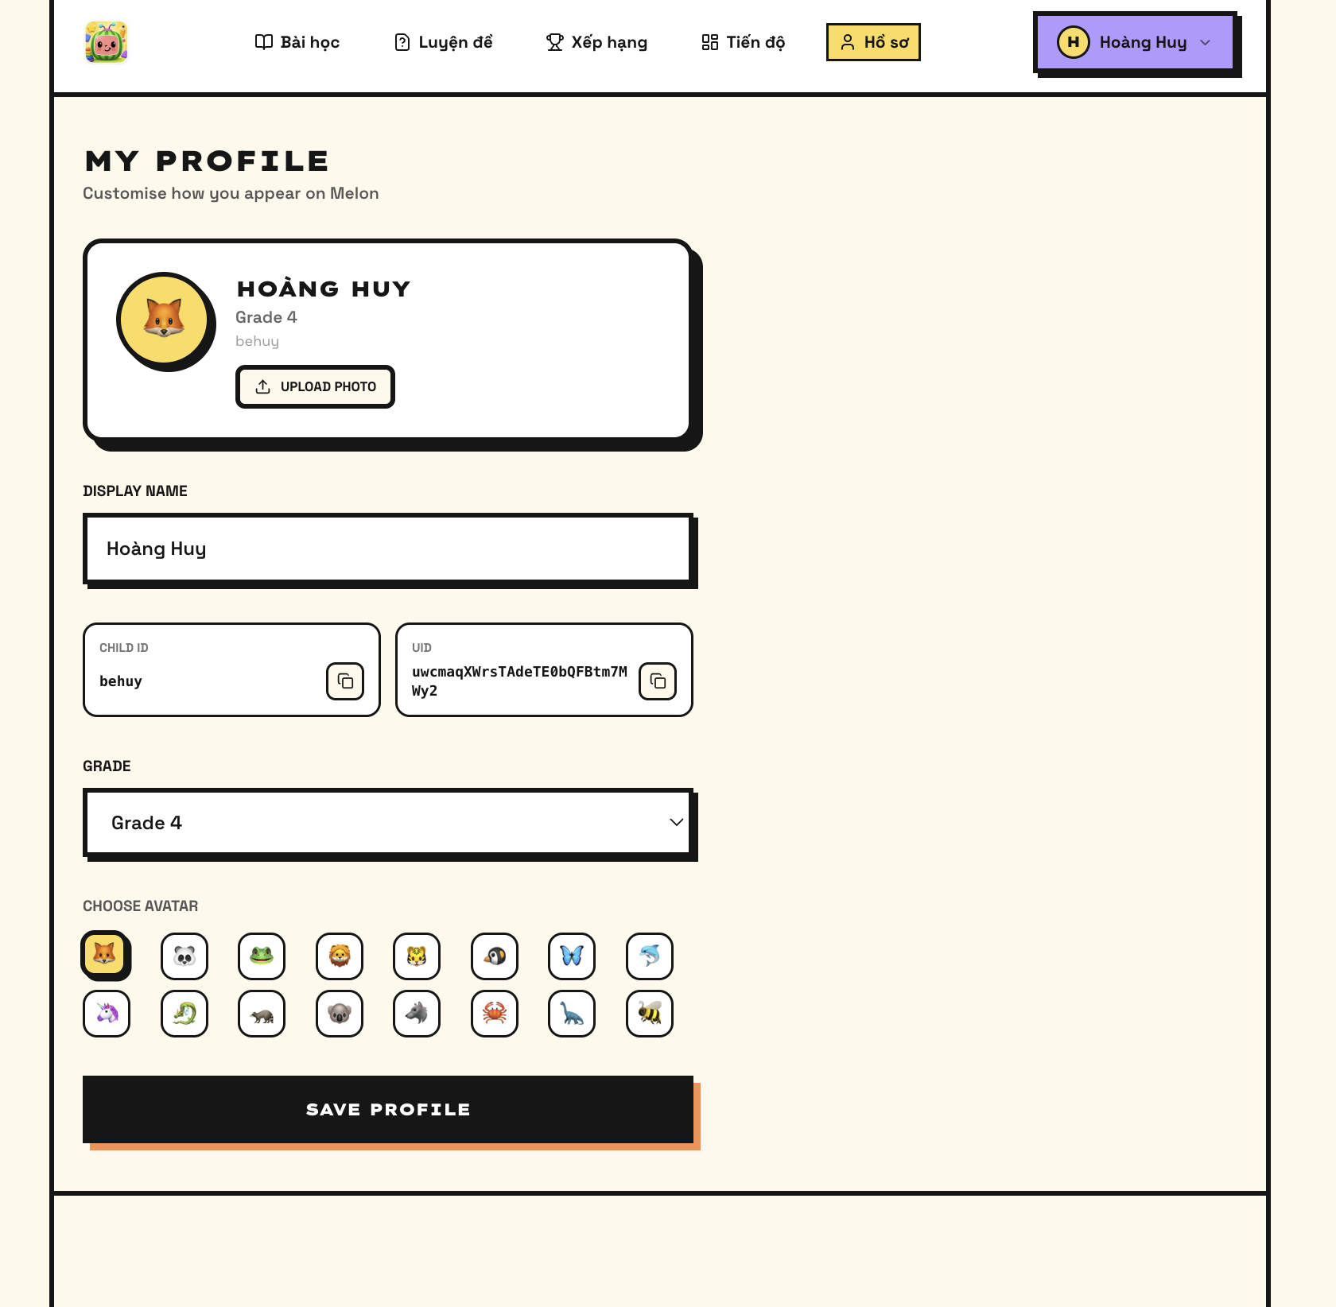
Figure 8. Child Profile Customization screen.
Purpose | Allows controlled personalization of the child profile while keeping profile identifiers visible for support or linking workflows.
What the screen shows | Profile card, avatar, display name, child ID, UID, grade selector, upload-photo action, avatar selection grid, and save-profile action.
How users use it | The user updates display name, avatar, grade, or profile image, then saves the changes. Avatar selection also supports future reward redemption and unlocked cosmetic items.
Use-case alignment | Aligned. Profile editing maps to UC-02.2, while the avatar and cosmetic personalization area supports the virtual reward concept in UC-06.5.

5.9 S09 - Admin Question Bank Review
Related use case(s): Supporting UC-04.2 Generate AI Quiz; Supporting UC-05.1 Content Safety Moderation
Scenario: Admin reviews generated or extracted question-bank content
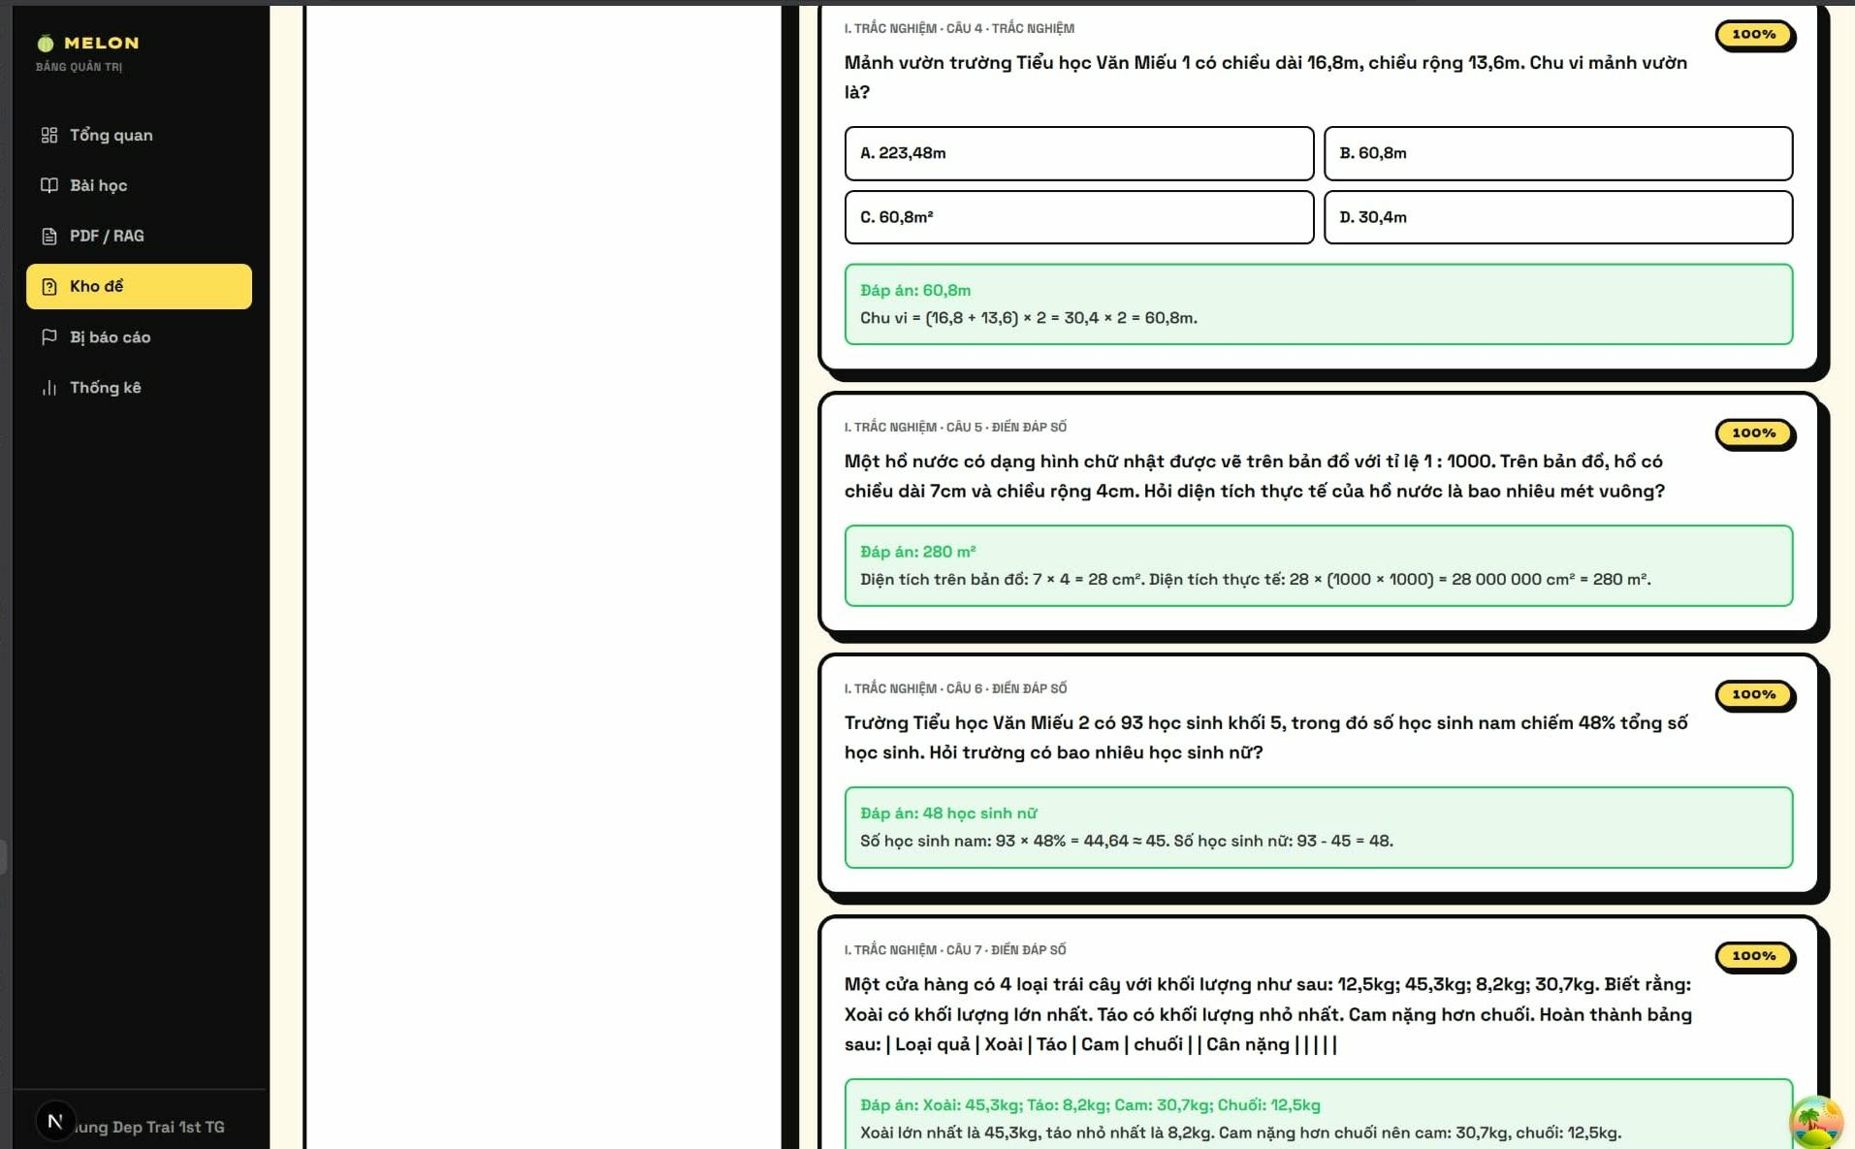
Figure 9. Admin Question Bank Review screen.
Purpose | Provides an administrative review surface for generated quiz items and question-bank quality control.
What the screen shows | Admin navigation menu, question-bank module, question cards, answer options, correct-answer indicators, solution explanations, and content review status.
How users use it | The administrator opens the question bank, checks whether extracted or generated questions are correct and safe, and prepares content for reliable learner-facing use.
Use-case alignment | Supplementary. The use-case specification does not define a standalone Admin question-bank use case. This screen is retained as a support screen for UC-04.2 and UC-05.1 but should not be counted as the only evidence for the mandatory key-scenario requirement.

